Name _________________________________
Date __________________________________
Semester _____________________________

7th Grade Band – Semester Final 2013
This is the written portion of your exam. The information on this test comes only from second semester class material. If you have any questions raise your hand and I will assist you. This portion of the exam is worth 100 points.

Part 1 – Tempo (2 point each)
Directions: Correctly match the tempo markings to the correct letter definition

____________1.) Allegro a.) Fast, Quickly and Bright

____________2.) Andante b.) Moderately

____________3.) Adagio c.) Slowly and Stately

____________4.) Moderato d.) At Walking Pace

Part 2 – Rhythm Counting (4points each)
Directions: Write in the counting for each measure. Make sure to look at your time signature and note values.

5.)
6.)

7.)

Part 3 – Dynamics/Styles/Signs (2 point each)
Directions: Arrange the following dynamic levels into the correct order from LOUDEST to SOFTEST (Ex. #8 will be the loudest dynamic, #11 will be the softest). Also write the symbol/abbreviation for each dynamic.

PIANO FORTISSIMO MEZZO PIANO MEZZO FORTE

8.) __________________________________ _________________

9.) __________________________________ _________________

10.) __________________________________ _________________

11.) __________________________________ _________________

Directions: Draw and describe what the following signs/symbols mean in regards to music (Ex. # = sharp, it raises the note or pitch.

Symbol Drawing Definition

12.) Repeat Sign _________________ ________________________________

13.) Crescendo _________________ ________________________________

14.) Decrescendo _________________ ________________________________

15.) Breath Mark _________________ ________________________________

Part 4 – Instruments/Families (2 points each)
Directions: Group the following instruments into the correct instrument family. Your choices are:
- a.) Woodwinds
- b.) Brass
- c.) Percussion
- d.) Strings

16.) Clarinet ________ 17.) Snare Drum ________ 18.) Trumpet ________

19.) Tuba________ 20.) Violin________ 21.) Cymbals________

22.) Timpani _______ 23.) French Horn __________

Part 5 – Composing (10 points)
Directions: Compose a four-measure song. Make sure to complete each measure with the correct number of beats. Each measure needs to contain at least 2 notes. You must also use the following elements within your composition:
- 1 Dynamic Level
- 1 Time Signature
- 1 Clef
- 1 Sign/Musical Symbol
- 1 Tempo Marking

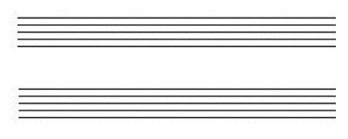

Part 5 – Reflection (18 points)
Directions: Using your experience at the concert compose a five sentence paragraph focusing around the following questions. A.) What were so things that you did good musically? B.) What are some techniques you need to improve on in the future? C.) How did the ensemble do overall? Make sure to use complete sentences.

___________________________________________________________________________________

___________________________________________________________________________________

___________________________________________________________________________________

___________________________________________________________________________________

___________________________________________________________________________________

___________________________________________________________________________________

___________________________________________________________________________________

___________________________________________________________________________________

___________________________________________________________________________________

___________________________________________________________________________________

___________________________________________________________________________________

___________________________________________________________________________________

___________________________________________________________________________________

___________________________________________________________________________________

___________________________________________________________________________________

Part 7 – Identification of Terms (20 Points)
Directions: Circle the following elements that are present inside this piece of music . Make sure to circle all that ii is asking for.

Circle the Following:

- Dynamics
- Tempo Marking
- Time Signatures
- Accidentals
- Composer
- Title of Piece
- Instruments
- Treble and Bass Clefs

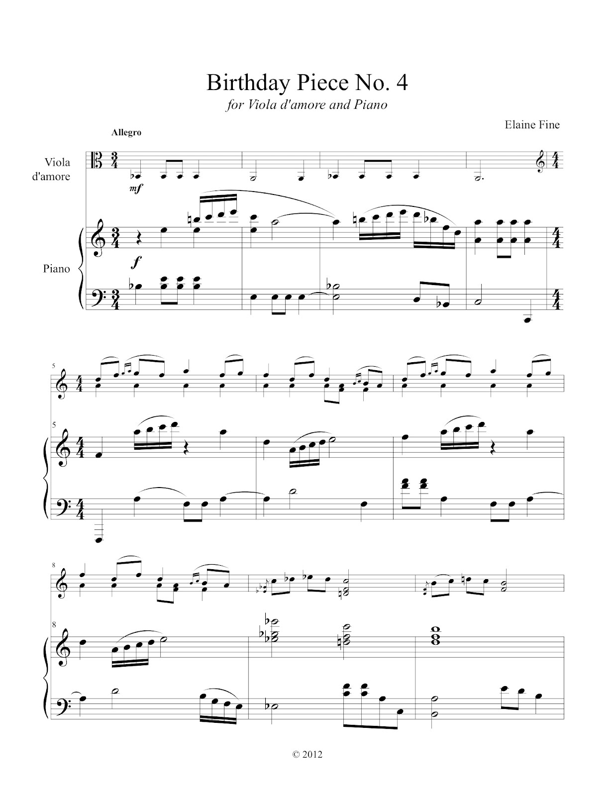

Name: _____________________________________ Date:____________________

Concert Rubric for 7th Grade Band (25 points)
The following adjudicator sheet is a replica of what the ISSMA official adjudicators use when they judge bands for their performances.

RATINGS:

4-Outstanding in nearly every detail 2-Frequent major flaws
3.5-Some minor flaws 1.5-Continuous major flaws
3-Frequent minor flaws 1-Unacceptable in nearly every detail
2.5-Some major flaws

Categories 1 1.5 2 2.5 3 3.5 4 General Remarks
Intonation
Consider: individual,
Section, and
Full ensemble
Tone quality and blend
Consider: resonance,
Control, clarity, focus,
Consistency, warmth,
And breath.
Articulation, tonguing
Consider: attacks
Releases, tonguing,
Style.
Note accuracy
Consider: Technique,
Fluency and/or
Mechanical skills
Rhythmic Accuracy
Consider: accuracy
Of note values,
Rest values, duration,
Pulse, steadiness,
Correctness of meters.
Interpretation and
Musicianship
Consider: style,
Phrasing, tempo,
Expression and
Emotional involvement

Dynamics
Consider: appropriate
Range of dynamic
Contrast by individuals,
Sections, and/or full
Ensemble.
Balance and Blend
Consider: appropriate
Range of dynamic
Contrast by individuals,
Sections, and/or full
Ensemble.
Other factors
Consider: posture,
Appearance relating
To performance,
General conduct,
Suitable cuts.

Total points __________________

